**CHAPTER ONE**

**1.0 INTRODUCTION**

**1.1 BACKGROUND OF STUDY**

With a highly saturated and competitive market in the fast-food industry, restaurant operators ought to be more selective in running their business strategies. Various brand names expand their networks into cities and offer a wide range of menu, prices and services, which could result to extreme competitive environment among the restaurants in winning and maintaining customers. Increasing competitive environment allows fast-food customers to choose among the available products and services with respect to personal preferences and brand names. (Wang, 2010) But, this can be improved if clients’ predictions are about 94% correct, that’s where data mining comes in. (Haghighi, 2012)

Data mining is the process of sorting through large data sets to identify patterns and establish relationships to solve problems through data analysis. Data mining tools allow enterprises to predict future trends. Data mining techniques are used in many research areas, including mathematics, cybernetics, genetics and marketing. While data mining techniques are a means to drive efficiencies and predict customer behavior, if used correctly, a business can set itself apart from its competition through the use of predictive analysis.(Margaret, 2019).

Aside from the raw analysis step, it also involves database and [data management](https://en.wikipedia.org/wiki/Data_management) aspects, [data pre-processing](https://en.wikipedia.org/wiki/Data_pre-processing) [model](https://en.wikipedia.org/wiki/Statistical_model) and [inference](https://en.wikipedia.org/wiki/Statistical_inference) considerations, interestingness, metrics, [complexity](https://en.wikipedia.org/wiki/Computational_complexity_theory) considerations, post-processing of discovered structures, [visualization](https://en.wikipedia.org/wiki/Data_visualization), and [online upd](https://en.wikipedia.org/wiki/Online_algorithm)ate Nowadays, marketing strategy has shifted from strategy that focuses on the brand (brand-centered) to client-focused strategy (client-centered). Many enterprises attempt to identify the factors that support customer satisfaction since it is a one of crucial business decision. As the heart of marketing, the ability to satisfy customers is great importance for many reasons. Customer satisfaction is the proportion between what is customer’s expectation and perceptions. (Hwang et al, 2017)

According to (Amir, 2015) In service industry, an increasing number of business owners improve the quality of service and reduce cost using big data techniques. Based on historical data of business, predictive models of machine learning can estimate future moves of customers. Especially, forecasting the number of future visitors can help restaurant owners make the best operations to maximize the revenue. With an accurate visitors forecasting model, restaurant owners can prepare suitable amount of ingredients that exactly satisfy future visitors.

In business perspective, customer satisfaction is a measure of how products and services provided by an enterprise meet customer expectations. (Ngia et al, 2009) In the context of fast-food industry, it is necessary to understand determinant factors driving customer satisfaction. For the restaurant managers, an understanding of underlying factors that influence customer satisfaction is a guidance to design services and offering. (Saad and Carolyn, 2006) Prior studies revealed the important attributes of customer satisfaction in restaurant. Since only few studies discussed customer satisfaction attributes in fast-food restaurant. Tangible (e.g. food quality and food presentation) and intangible (e.g. staff behavior and restaurant atmosphere) attributes were considered. Several studies also indicate that nonfood-related attributes such as restaurant environment and staff friendliness were the determinant factors contributing to customer experience in restaurant. With a highly saturated and competitive market in fast-food industry, restaurant operators ought to be more selective in running their business strategies. In other to improve the income and patronage of some restaurants, various brand names expand their networks into cities and offer a wide range of menu, prices and services, which could result to extreme competitive environment among the restaurants in winning and maintaining customers. Increasing competitive environment allows fast-food customers to choose among the available products and services with respect to personal preferences and brand names. Consequently, most of fast-food customers cannot be considered as potential loyal customers.

A strong relationship between customer satisfaction and customer loyalty is derive from managing customer experience. Some studies revealed findings that managing customer experience has potential association with food related attributes. For example, some attributes such as taste, staff behavior, and food design has identified as key factors in developing customer experience in restaurant. Similarly, some attributes such as food presentation, staff competency, and food taste become the key to customer satisfaction.

This study also revealed underlying factors of customer satisfaction restaurant such as staff behavior. It recommended that restaurant operators understand required attitude when serving customers. Several crucial aspects regarding staff behavior such as staff’s attitude, gesture, and emotional intelligence in facing and serving customers. Likewise, adequate staff training such as motivational training, basic customer service training aimed at enabling fast-food restaurant to offer excellent service to their customers. Lastly, continuous evaluation of the quality of customer. Therefore, the objective of this paper is to analyze Restaurant Clients’ Visit Pattern using decision tree and then neural network for predicting if a customer would churn or not.

**1.2 STATEMENT OF PROBLEM**

Nowadays, marketing strategy has shifted from strategy that focuses on the brand (brand-centered) to customer-focused strategy (customer-centered). Thus leading restaurant to prioritize on customer’s satisfaction. The right algorithm put in place to analyze the pattern of customers will be able to allow prediction and make best use of resources, leading to customer’s satisfaction. By using software to look for patterns in large batches of data, restaurants can learn more about their customers to develop more effective marketing strategies increase sales and decrease loss.

Different machine learning algorithm are applied in the areas of economic industry. In this paper we would be using machine learning algorithm to predict customers churn in restaurant.

**1.3 MOTIVATION FOR THE STUDY**

Managing customer satisfaction has become a crucial issue’s in Restaurant especially in terms of visiting pattern. This study aims at identifying determinant factors related to customer satisfaction in fast-food restaurant. Customer’s data would be analyzed using data mining method with two classification techniques such as decision tree and neural network. Classification models are developed using decision tree and neural network to determine underlying attributes of customer satisfaction.

**1.4 AIM AND OBJECTIVES OF STUDY**

**1.4.1 AIM**

The aim of this study is to analyze Restaurant clients visit pattern using decision tree and then neural network for predicting customer churn.

**1.4.2 OBJECTIVE**

The objectives are as follows.

1. To collect data associated to customers visiting a restaurant.
2. To prepared, the data collected and make it ready for prediction.
3. To apply the expected algorithm on the data to develop a model.
4. To train the model.
5. To evaluate the performance of the model.
6. To test the model

**1.5 METHODOLOGY OF STUDY**

This study adopts soft-computing methodology. In other to achieve the aim of this work, the following procedure to achieve a successful implementation here:

Data collection

Data Preparation

Model Building

Classification Algorithm

(Decision Tree and ANN)

Result

Train model

Evaluate model

Test model

Figure 1: Diagram showing the study methodology

1. **Data Collection:** This stage involve the process where the data for the experiment would be collect. The dataset used was from https://www.kaggle.com/huzaiftila/customer-churn-prediction-analysis. This dataset contains historical data of customers visiting a restaurant with a target label specifying if a customer would keep patronizing or not (churn).
2. **Data Preparation:** The data collected would be preprocessed to ensure all data are in the right format. Wrangle data are prepare for training. It also ensure all data in a particular columns maintain the same data type and suit the machine learning algorithm to be used
3. **Model Building:** In this work, the researcher would adopt the use of Decision Tree and ANN respectively algorithm, which would be implemented using WEKA as our development environment.
4. **Train Model:** This process involves applying the selected algorithm on the selected dataset.
5. **Evaluating Model:** After the model had been trained. We find the Accuracy of the model, Its precision and recall to identify the performance of the model built.
6. **Testing Model:** This process involves testing the model built with a newly set of dataset for so the model would predict the targeted variable.
7. **Result:** This is the output of the prediction.

**1.6 Proposed Model**

**1.6.1 Conceptual Model**

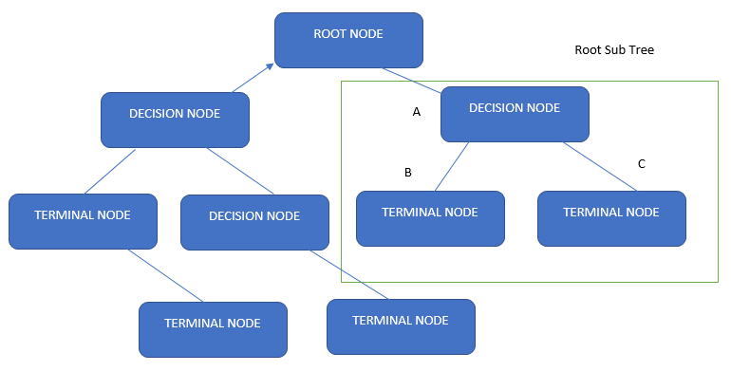

**Figure 1.1 Decision Tree Conceptual Model**

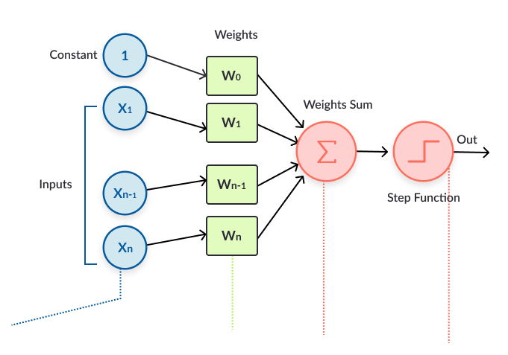

Figure 1.2 Conceptual Model For Artificial Neural Network

**1.6.2 Mathematical Model**

The mathematical model for neural network is as follows:

**The Forward Propagation (forward pass):**

The activation function of the artificial neurons in ANNs implementing the forward propagation and of the sum of the inputs (xi)multiplied by their respective weights (wji). where (xi) are attributes and (wji) are the weight of attributes in each case.

Aj(x,w) = ∑n**i** = 0xiwji (1)

The activation function depends only on the inputs and the weights. The most common output function is the sigmoidal function:

Oj(x,w) = 1 / (1+eAi(x,w)) (2)

The goal of the training process is to obtain a desired output when certain inputs are given. Since the error is the difference between the actual and the desired output, the error depends on the weights, hence the weights of each attributes are adjusted in order to have a minimal error. The square of the difference between the output and the desired target is taken because it will always be positive, so it is greater if the difference is big and lesser if the difference is small. The total error of the model will simply be the sum of all errors of each neuron. We can define the error function for the network (model) output:

Ej(x,w,d) =∑ (Oj(xi,wji) – dj)2 (3)

**The Backward Propagation (backward pass):**

The backpropagation algorithm now calculates how the error depends on the output, inputs, and weights. After this is found, the weights can be adjusted using the method of gradient descent:

**∆**wji = E **/ $∂$** wji (4)

This formula can be interpreted as: the adjustment of each weight (**∆**wji) will be the negative of a number multiplied by the dependence of the previous weight on the error of the network, which is the derivative of E in respect to (wji). The size of the adjustment will depend on the number and the contribution of the weight to the error of the function. If the weight contributes a lot to the error, the adjustment will be greater than when it contributes in a smaller amount. The goal of the backward pass algorithm is to find the derivative of E in respect to wji. So first, we calculate how much the error depends on the output, which is the derivative of E in respect to Oj (from (3)).

$∂$ E **/ $∂$** wji = 2(Oj **-** dj)(5)

­And then how much the output depends on the activation, which also depends on the weights (from (1) and (2)):

$∂$ Oj **/** w= $(∂$ Oj **/** ajaj **/** wji) = Oj(1 - Oj)xi (6)

Then (from (5) and (6))

$∂$ E **/ $∂$** wj = Ej **/** OjOj **/** wj)= 2(Oj- dj) * Oj (1 – Oj)xi (7)

Therefore, the adjustment to each weight will be (from (4) and (7)):

**∆**wji = 2(Oj- dj) * Oj(1 – Oj)xi (8)

Finally, the goal of the backward propagation (pass) is achieved by adjusting the weights of each attributes, thereby minimizing the error of the network (model).

**Decision Tree Mathematical Model**

Lets see decision tree with this simple example, It is normal “AND’ operation problem, where ‘A’, ‘B’ are features and “A and B” are corresponding labels.

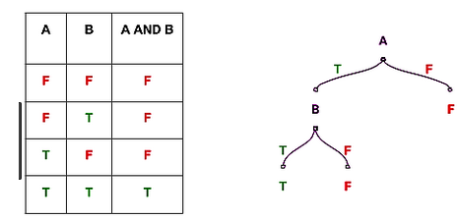

If A=F then result=F

If A=T and B=T, then result=T

If A=T and B=F, then result = F

This is an example of binary classifier. It classify “And” operation is ‘False’ or ‘True’.

Decision tree algorithm uses entropy to calculate the homogeneity of a sample. If the sample is completely homogeneous the entropy is zero and if the sample is an equally divided it has entropy of one.

To build a decision tree, we need to calculate two types of entropy using frequency tables as follows:

1. Entropy using the frequency table of one attribute:

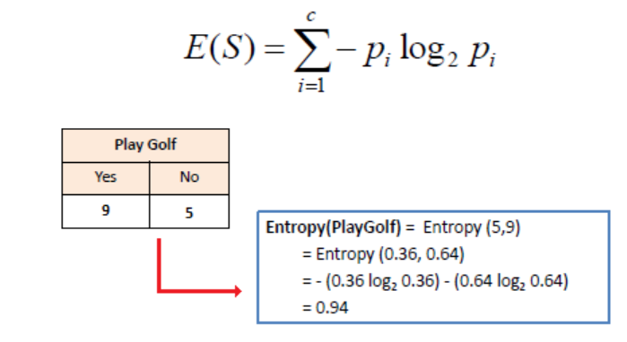

b) Entropy using the frequency table of two attributes:

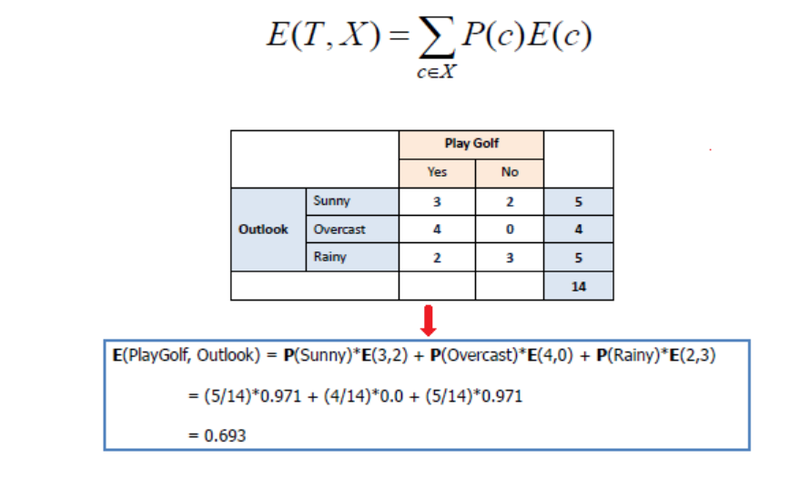

Information gain is calculated as;

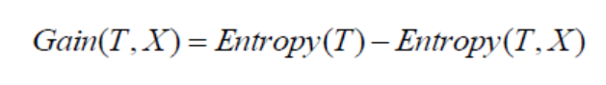

**1.7 The Scope of the Study**

This research work focuses on the analyzing Restaurant Clients’ dataset using Neural Network and Decision tree to predict the outcome of a customer behavior in a super market.

**1.8 SIGNIFICANCE OF THE STUDY**

This study will be of immense benefit in that;

1. It helps reduce possibilities of the restaurants losing customer.
2. It helps businesses get closer to their objective and make better decisions.

**1.9 Organization of Write-up**

**1.10 Definition of Terms**

**Restaurant:** a place where people pay to sit and eat meals that are cooked and serve on the premises based on preference.

**Client:** a person or organization in search of the services of an offering body

**Visitor:** a person visiting someone or somewhere especially socially

**Data:** facts and statistic gathered and collected for reference or analysis.

**Data Mining:** the practice in computing of examining large pre-existing database in order to generate new information.

**Analysis:** detailed examination of elements or structure of something.

**Prediction:** To make an estimate something that will happen before it does.